Department of Procurement Services
124724 Research Parkway, Suite 355
Orlando, FL 32826

ADDENDUM

IMPORTANT DOCUMENT – INVITATION TO BID

ITB NUMBER: 2021-16GC OPENING DATE & TIME: March 22, 2022 @ 3:00 p.m.
ITB TITLE: PULSE COMPRESSION UNIT
ADDENDUM NUMBER: 2 ADDENDUM DATE: MARCH 15, 2022

Purpose of this addendum is to:

- Answer questions submitted by vendors.

PLEASE ACKNOWLEDGE RECEIPT OF THIS ADDENDUM AND RETURN IT WITH YOUR BID. FAILURE TO SIGN AND RETURN WITH YOUR BID COULD RESULT IN REJECTION OF YOUR BID.

PROPOSERS SIGNATURE PRINT OR TYPE PROPOSER’S NAME

COMPANY NAME EMAIL ADDRESS

Answers to Questions
ITB 2021-16GC
PULSE COMPRESSION UNIT

- Vendor question: What is the repetition rate?

UCF Answer: 100kHz

- Vendor question: Bandwidth of the laser

UCF Answer: ~1500-2600nm

- Vendor question: Spatial properties of the laser (M², Divergence, Beam Diameter)

UCF Answer: M^2<1.3, divergence: not available, Beam diameter: not available

- Vendor question: Footprint available for the compression unit

UCF Answer: 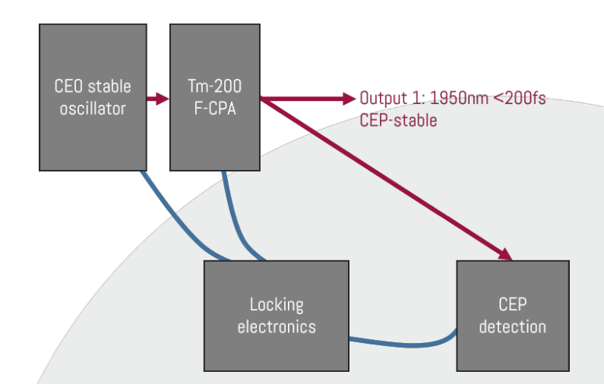

- Vendor question: Repetition rate of the laser system at UCF

UCF Answer: See question 1

- Vendor question: Energy per pulse of the laser system

UCF Answer: 2mJ/pulse

- Vendor question: Beam size (at 1/e^2)

UCF Answer: Not available

- Vendor question: M^2 (m-squared, or quality factor) of the beam from the laser system

UCF Answer: See question 3

- Vendor question: A typical output spectrum of the system - can also be data from the manufacturer in case the system is not yet installed at UCF.

UCF Answer: It is a custom system. Data is not yet available.

- Vendor question: Complete data/specs of the laser system, including manufacturer and model

UCF Answer: Manufacture: Active Fiber Systems (AFS). Custom system.

- Vendor question: What is your expected delivery time for the system?

UCF Answer: Jan 2023

